1. Introduction (Expanded from the Proposal)
- Context of Database Evolution:
  - Database Modeling History: Start by discussing the history of database modeling, beginning with early relational databases and the development of the Entity-Relationship (ER) model.
  - Data Normalization: Explain normalization and how it reduces redundancy and improves integrity. Describe how normalized databases (3NF) were used traditionally but presented challenges for analytical queries due to the complexity of joins.
  - Introduction of OLAP: Introduce OLAP (Online Analytical Processing) and Dimensional Modeling as techniques designed for efficient querying in data warehouses, which led to the rise of star schemas.
- Star Schema in Data Warehousing:
  - What is a Star Schema?: Explain that the star schema is a type of dimensional model that organizes data into fact tables (numeric performance measures) and dimension tables (descriptive attributes). It is optimized for reading and querying large datasets.
  - Importance in BI Systems: Discuss how the star schema simplifies the design and querying of data warehouses and facilitates fast reporting and analytics. Business Intelligence (BI) systems often use star schemas to improve query performance and reduce complexity.
- Why Choose the Star Schema?:
  - The simplicity of the star schema: It is easy to understand and implement compared to other schema types like the snowflake schema.
  - The speed of queries: Because of its denormalized nature, star schemas enable faster queries compared to normalized schemas, especially for complex aggregations or OLAP operations.
  - Real-World Use Cases: Companies like Amazon, Netflix, and Walmart use data models similar to the star schema to handle large-scale data analysis and improve decision-making.

Expanded Example:
- Historical Data Modeling: Traditional systems used normalized databases where data is split across multiple tables. For example, a table for customers, one for orders, and another for products. This led to complex SQL queries for analytical tasks.
- OLAP and Dimensional Modeling: OLAP cubes and dimensional modeling were developed to address the inefficiencies of normalized models in large-scale analytics.
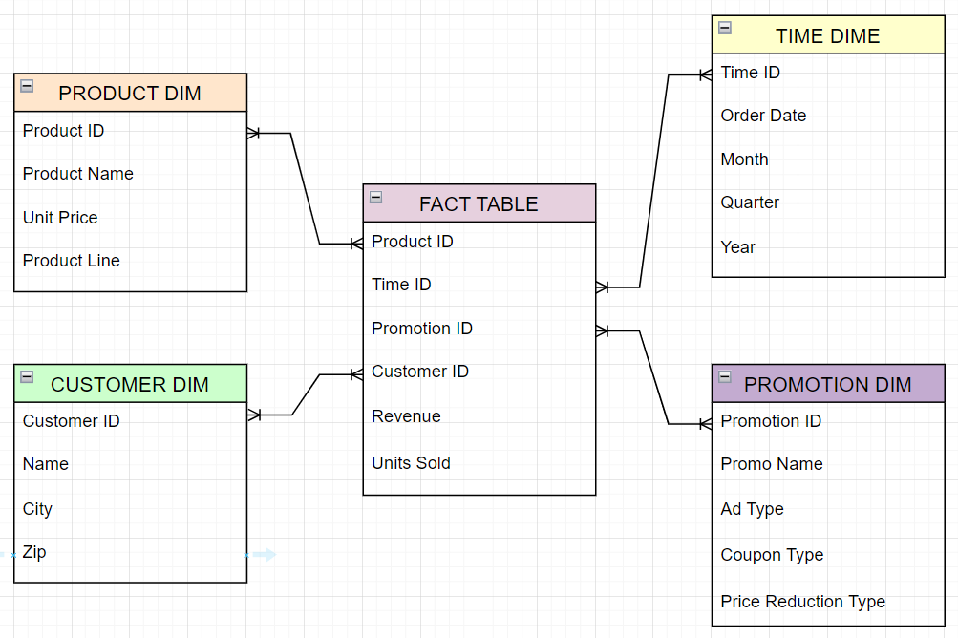

2. Star Schema Design
- Design Components:
  - Fact Table:
    - The Fact Table is the central table in a star schema, and it contains measurable, quantitative data. It tracks key business events, and in this case, the fact table contains transactional data such as Revenue, Units Sold, Product_ID, Customer_ID, and Time_ID.
    - In the context of this schema, the fact table is designed to capture the transaction details for sales, including the relevant connections to each of the dimensions: Product, Customer, Time, and Promotion.
  - Key fields in the Fact Table:
    - Product_ID: Foreign key linking to the Product Dimension.
    - Customer_ID: Foreign key linking to the Customer Dimension.
    - Time_ID: Foreign key linking to the Time Dimension.
    - Promotion_ID: Foreign key linking to the Promotion Dimension.
    - Revenue: Numeric value representing the sales revenue for the transaction.
    - Units Sold: Quantity of items sold in the transaction.
- Dimension Tables:
  - Product Dimension:
    - Fields: Product_ID, Product_Name, Unit_Price, Product_Line
    - This table contains descriptive information about each product, such as the product's name, unit price, and its category (product line).
  - Customer Dimension:
    - Fields: Customer_ID, Name, City, Zip
    - Contains details about the customer, including their name and geographic location.
  - Time Dimension:
    - Fields: Time_ID, Order_Date, Month, Quarter, Year
    - Stores information about the date of the transaction, split into components such as month, quarter, and year for analytical purposes.
  - Promotion Dimension:
    - Fields: Promotion_ID, Promo_Name, Ad_Type, Coupon_Type, Price_Reduction_Type
    - Contains information about any promotional activity related to the transaction, such as the type of promotion or discount used.
  - Detailed Schema Diagrams:
    - Schema Design Example: You can include the diagram showing the Fact Table at the center, connected to the Product, Customer, Time, and Promotion dimension tables.
    - Explanation: The fact table captures data about each sales transaction. The dimension tables provide context for each transaction, allowing for easy reporting and analysis on a wide range of criteria.

3. Benefits and Challenges
- Benefits:
  - Simplified Queries:

    - The star schema allows for simpler queries compared to normalized schemas. By denormalizing the data into dimension tables, joins are minimized and queries become faster.
    - For example, a query to calculate total sales for each product becomes straightforward, as it involves joining the fact table to just a few dimension tables.
    - Example Query:
SELECT
p.Product_Name,
SUM(f.Revenue) AS Total_Sales
FROM
FactTable f
JOIN
ProductDim p ON f.Product_ID = p.Product_ID
GROUP BY
p.Product_Name;

- Improved Performance:
      - The star schema enables quicker data retrieval by reducing the number of tables that need to be accessed and joined during a query. Since the data is pre-aggregated in a denormalized format, queries that involve aggregations or grouping can be processed much faster than in normalized schemas.

    - Better for Reporting:
- BI Tools: Star schemas are ideal for reporting and analysis, particularly in Business Intelligence (BI) systems. BI tools such as Tableau, Power BI, or custom dashboards can query star schemas efficiently and provide insights quickly, improving decision-making.
Challenges:
- Redundancy:
- Because the star schema denormalizes dimension data (storing the same data multiple times in different records), there can be redundancy. This can lead to larger storage requirements, especially in very large databases.

- Data Integrity:
  - Updating dimension data (e.g., correcting a product name or customer information) can be more challenging because the redundant data needs to be updated in multiple places.

- Increased Storage:
  - While queries may be faster, the storage requirements increase because the schema stores repeated data in dimension tables. This can lead to significant overhead for large datasets.

4. SQL Queries
- Simple SELECT Query Example:
  - The SELECT query retrieves the total revenue by product from the fact table, joining the fact table with the product dimension to display the product names:
SELECT
p.Product_Name,
SUM(f.Revenue) AS Total_Sales
FROM
FactTable f
JOIN
ProductDim p ON f.Product_ID = p.Product_ID
GROUP BY
p.Product_Name;

- Aggregation Queries:
  - The star schema makes it easy to perform complex aggregations. For example, to calculate the total units sold per customer across different time periods, we can use:

SELECT
c.Name,
SUM(f.Units_Sold) AS Total_Units_Sold
FROM
FactTable f
JOIN
CustomerDim c ON f.Customer_ID = c.Customer_ID
GROUP BY
c.Name;

5. Performance Metrics

Query Performance Comparison:
- Benchmarking: To compare the performance, you can run a similar query on a normalized schema and a star schema, measuring execution times.
Example comparison:

Query Type Star Schema Time Normalized Schema Time
Simple Aggregation (SUM) 1.2 seconds 3.5 seconds
Join Query (Multiple Tables) 2.5 seconds 7.5 seconds

- Query Execution Time:
  - In a star schema, the execution time will often be faster, particularly for aggregations or counting operations, since fewer joins are required.
- Indexing: Indexes on the fact table and dimension tables can improve query performance. For example, indexing the Product_ID in both the fact table and product dimension table can speed up the join process.

6. Screenshots and Demonstration Details
- Screenshots: Include diagrams and screenshots of the schema, showing how data is structured. Show the relationships between the fact and dimension tables.
- Demonstration Process: Describe the setup, how the database was created, populated with sample data, and how queries were executed. Show the SQL query results for the given queries.

7. Conclusion

- Summary of Benefits: The star schema is widely used due to its simplicity, faster queries, and better reporting capabilities. Its use in data warehousing and OLAP systems provides an optimized structure for analytical queries.
- Real-World Applications:
  - In industries like e-commerce and telecommunications, star schemas are crucial for managing large transactional datasets and providing fast insights. Companies like Amazon and Netflix use star schema-like structures to analyze vast amounts of data.
- Practical Use Cases: Discuss how companies like Walmart and Target benefit from using star schemas in inventory management, sales reporting, and customer behavior analysis.

